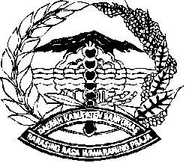

PEMERINTAH KABUPATEN BANYUMAS

##### KECAMATAN PURWOKERTO UTARA

Jl. Prof. Dr. H.R Bunyamin Nomor 3 Purwokerto Kode Pos 53121

Telp/Faks. (0281) 635028 Email : purwokertoutara@banyumaskab.go.id

Website : https://purwokertoutarakec.banyumaskab.go.id

|  |  |  |  |  |
| --- | --- | --- | --- | --- |
| NOTA - DINAS | | | | |
|  |  |  |  |  |
| Kepada | : |  | | |
| Lewat | : |  | | |
| Dari | : |  | | |
| Tanggal | : |  | | |
| Nomor | : |  | | |
| Sifat | : |  | | |
| Lampiran | : |  | | |
| Hal | : |  | | |
|  |  |  |  |  |
| ………………………………………………………………………………………………..  ………………………………………………………………………………………………………….  ………………………………………………………………………………………………………….  ………………………………………………………………………………………………..  ………………………………………………………………………………………………………….  …………………………………………………………………………………………………………. | | | | |
|  |  |  |  |  |
|  |  |  | CAMAT PURWOKERTO UTARA  Dra. ERNY INDRIASTUTY, M.M  Pembina Tingkat I  NIP. 19670420 199403 2 009 | |
|  |  |  |  |  |
|  |  |  |  |  |