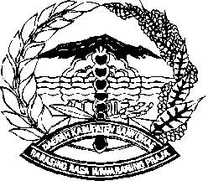

PEMERINTAH KABUPATEN BANYUMAS

##### KECAMATAN PURWOKERTO UTARA

Jl. Prof. Dr. H.R Bunyamin Nomor 3 Purwokerto Kode Pos 53121

Telp/Faks. (0281) 635028 Email : purwokertoutara@banyumaskab.go.id

Website : https://purwokertoutarakec.banyumaskab.go.id

|  |  |  |  |  |
| --- | --- | --- | --- | --- |
|  |  |  | Purwokerto, | |
|  |  |  |  |  |
| Nomor | : | ………….. |  | Kepada |
| Sifat | : | ………….. | Yth. | …………………… |
| Lampiran | : | ………….. |  |
| Hal | : | ………….. |  |
|  |  | di - |  |
|  |  |  | …………………… |
| ……………………………………………………………………………………………….  ………………………………………………………………………………………………………..  ………………………………………………………………………………………………………..  ………………………………………………………………………………………………………..  ………………………………………………………………………………………………………..  ……………………………………………………………………………………………………….. | | | | |
|  |  |  |  |  |
|  |  |  | CAMAT PURWOKERTO UTARA  Dra. ERNY INDRIASTUTY, M.M  Pembina Tingkat I  NIP. 19670420 199403 2 009 | |
|  |  |  |  |  |
| Tembusan :   1. ……………….. 2. ……………….. 3. Arsip (Bidang …………). | | |  |  |
|  |  |  |  |  |